**Social account log in project set up instructions**

1. This project uses Google log in and Facebook log in. The project only includes one *index.html* file. URI <http://localhost:5500> is listed in both Google and Facebook API configurations. *Localhost:5500* can be activated by running Live Server Extension in VS Code. Follow below steps to run the project:

* Open index.html in VS Code
* Activate localhost:5500
* In web browser, go to <http://localhost:5500>. Google Chrome is recommended. Make sure that you use <http://localhost:5500> instead of <http://127.0.0.1:5500> because the latter URI is not included in the Google and Facebook configuration for this project. Be aware that if you use Live Server Extension in VS Code, when “Go Live” the local host, it will open <http://127.0.0.1:5500/index.html> by default.

1. Project setup
2. Google console APIs & Services configuration:

* In Console Cloud Google, create a project
* In that project, go to APIs & Services -> OAuth consent screen to create an app (select external)
* Fill in all required information such as App name, User support email, etc
* On Scopes page, click Add or Remove scopes, then select /auth.userinfo.email, /auth.userinfo.profile, /auth.userinfo.openid

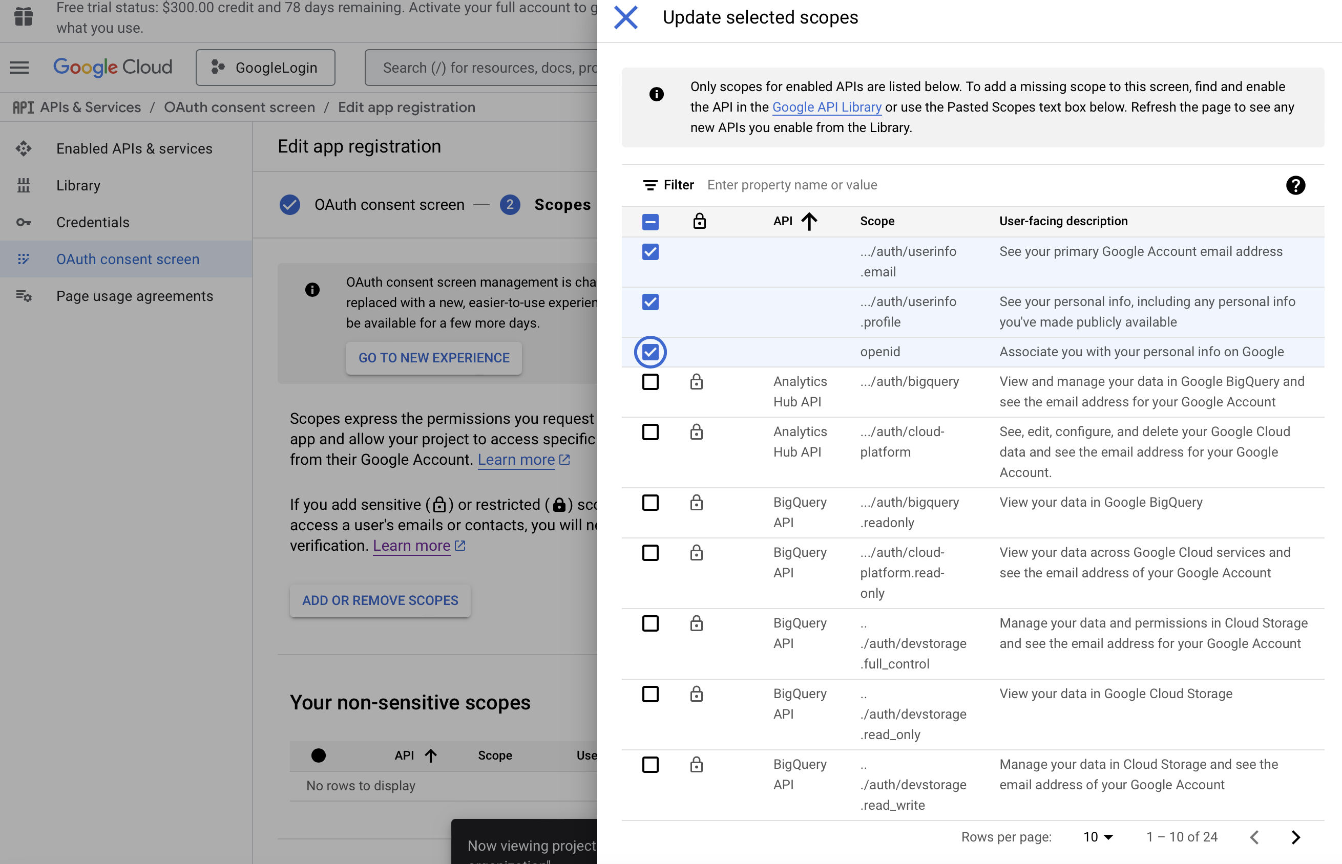

* In Credentials page, create a new Client ID and add <http://localhost:5500> to the URI and JavaScript origins

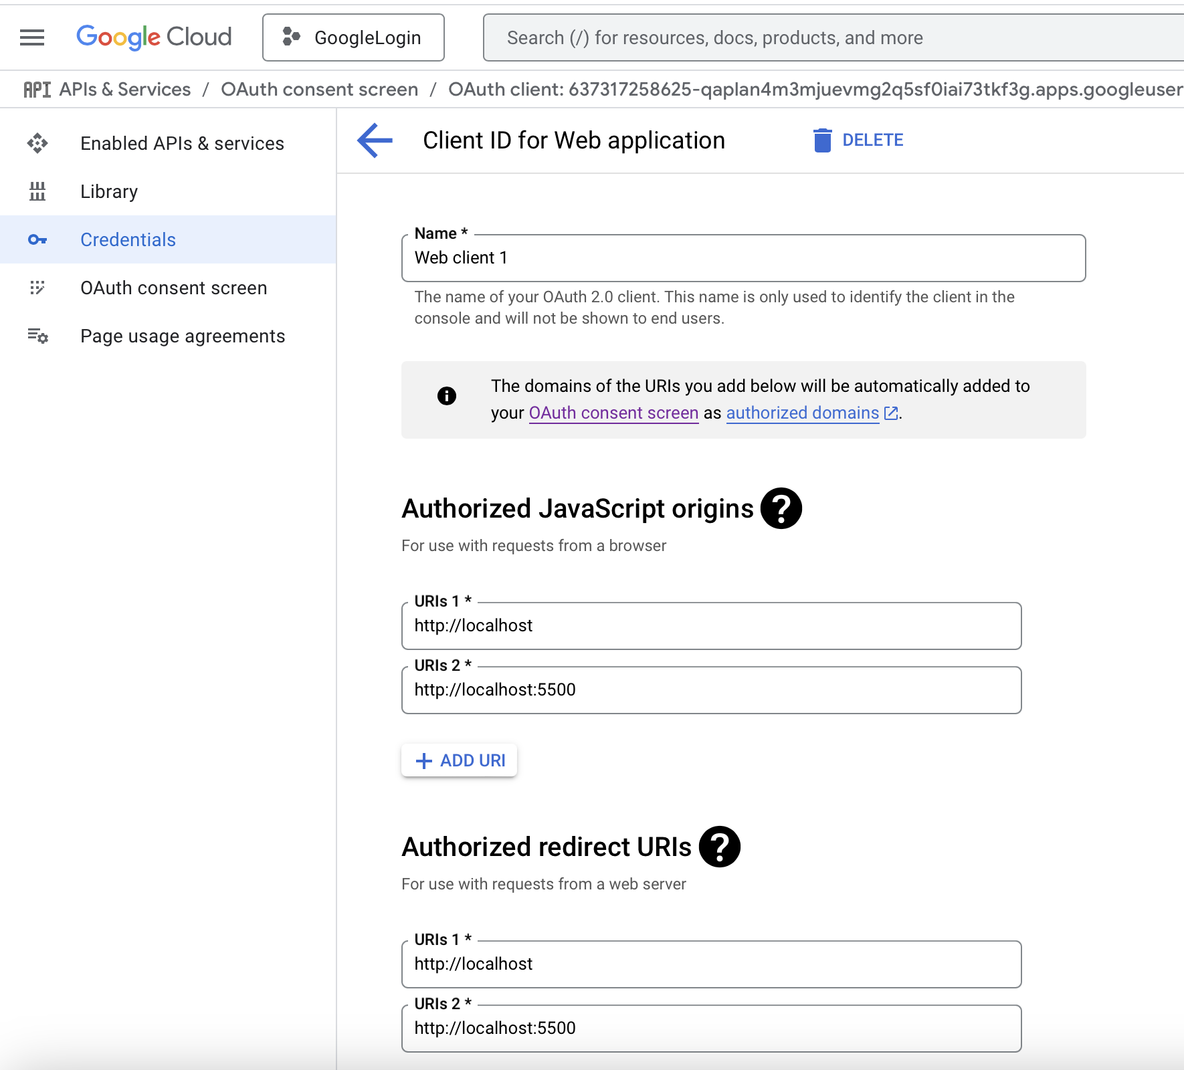

* After complete these steps, Client ID and Client secret are generated. Save this info to use in the code later

1. Facebook API configuration:

* In Facebook Development Console, create a new app
* Fill in app name
* Select Authenticate and request data from users Facebook Login for User case
* Go to User case -> quick start and select “Web”

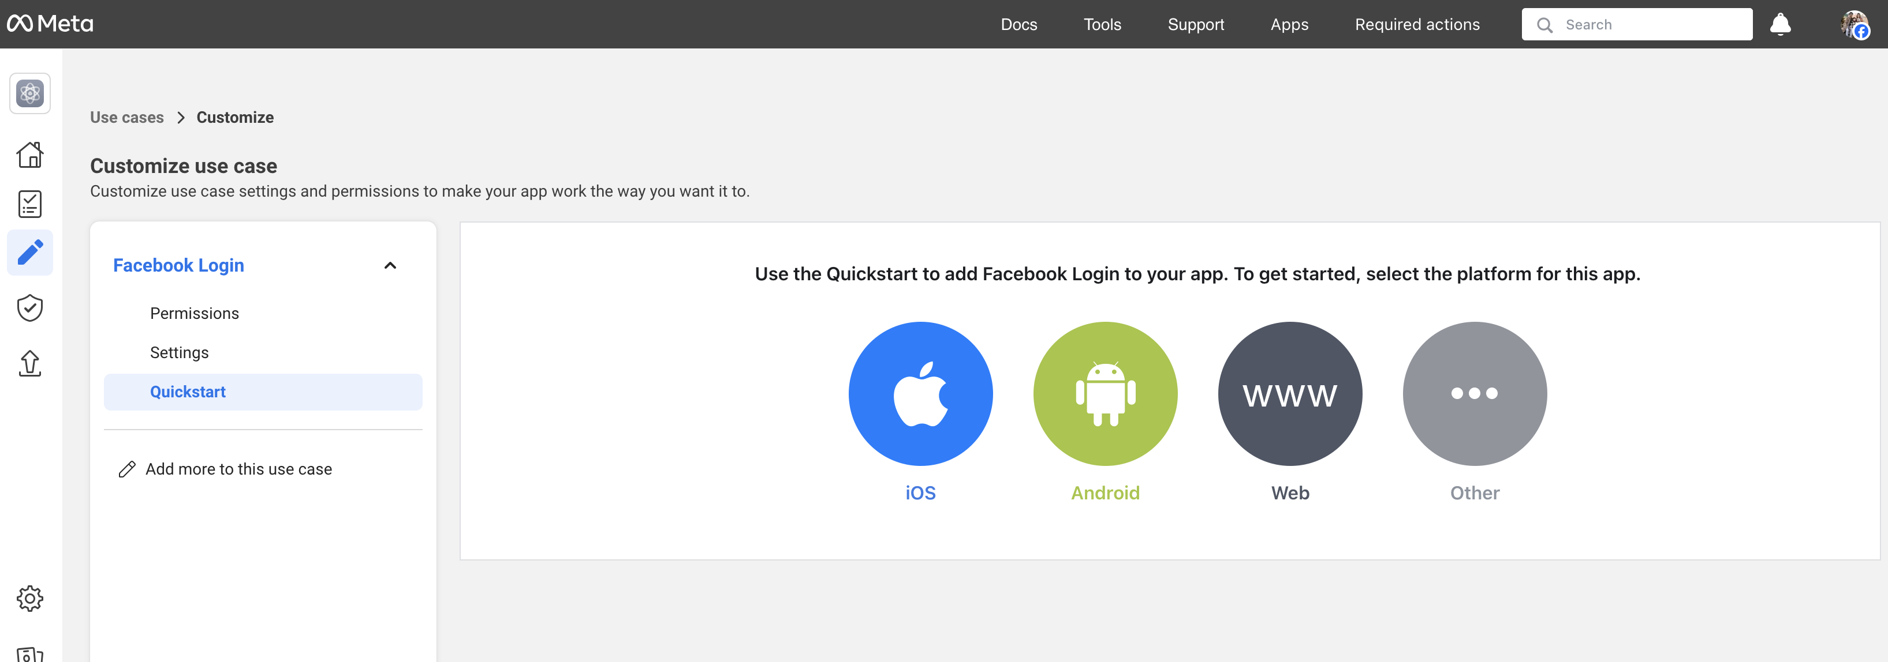

* Add <http://localhost:5500/> to the Site URL

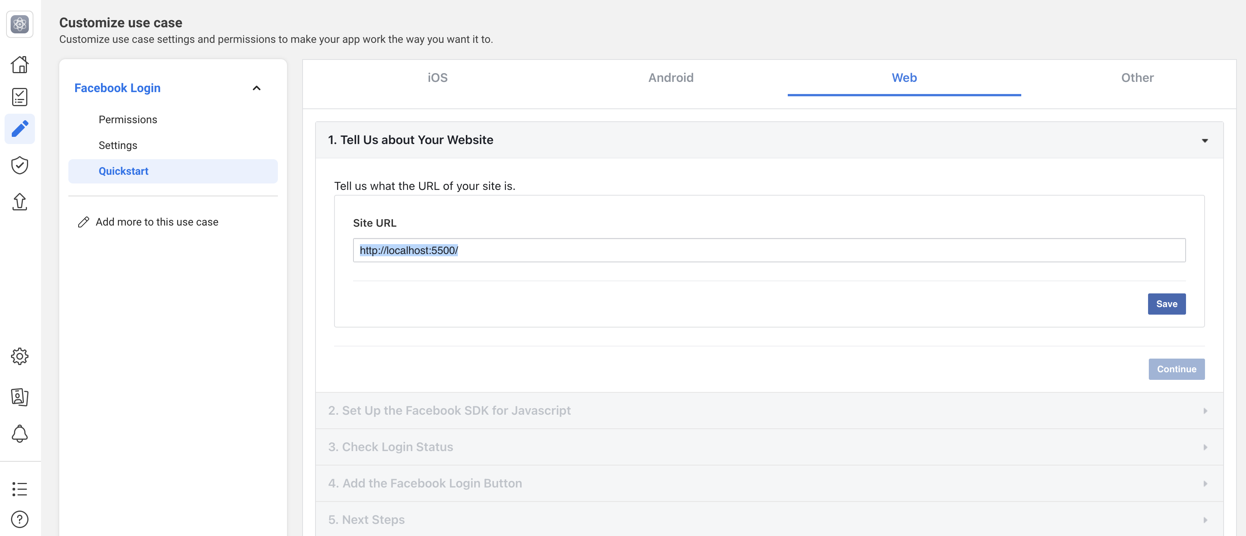

* Go to App settings -> Basic to get the App ID number to use later in the code

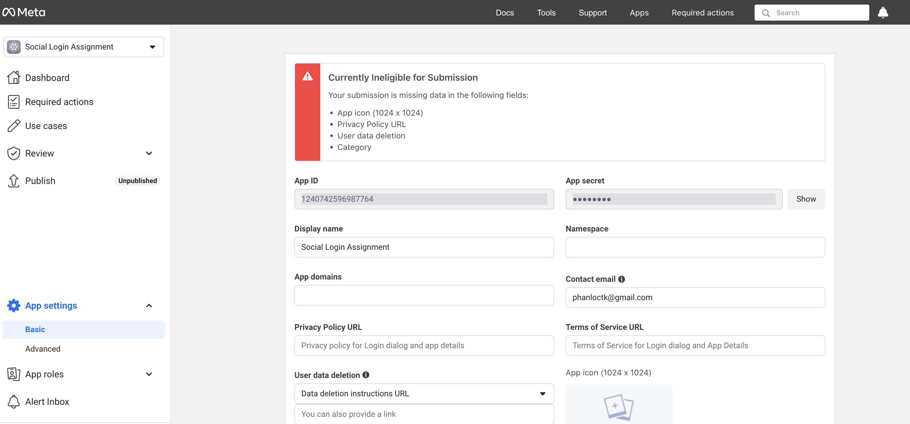

1. Index.html code explanation
   1. Google account log in

Add google account library <script src="https://accounts.google.com/gsi/client" async defer></script>

* + 1. Initialize Google Sign-in function *google.accounts.id.initialize()* and add the client_id
    2. render Google sign-in button using *google.accounts.id.renderButton()*. When click this button, it will trigger the Google Sign-in flow
    3. A log in prompt will be sent by Google to prompt user to log in. When user logs in, Google will send a token to the server and the callback function *handleCredentialResponse()* is called. Function *jwt_decode()* is used to decode the JWT token. To use this function, you need to add the jwt-decode library <script src="https://cdn.jsdelivr.net/npm/jwt-decode@3.1.2/build/jwt-decode.min.js"></script>
    4. after decoding the token, display the user information *displayGoogleUserInfo ()* and store information into Local Storage. To use Local Storage, several commands are used *localStorage.getItem()*, *localStorage.setItem(), JSON.parse(), JSON.stringify()*
    5. Logout: when click Google Logout button, *GoogleLogout()* function is called. This function will revoke google user credential using *google.accounts.id.revoke()* function.
  1. Facebook account log in
     1. Initialize Facebook SDK asynchronously using *FB.init ()* function.
     2. Load Facebook SDK asynchronously using script js.src = "https://connect.facebook.net/en_US/sdk.js"
     3. Check login status with *FB.getLoginStatus()* function. If login is successful, use function *fetchFacebookUserInfo()* to retrieve. Inside *fetchFacebookUserInfo(),* the function *FB.api()* is called to request user ID, name, email from Facebook API. Then display and store user information to the Local Storage
     4. Logout: when click Facebook Logout button, *facebookLogout()* function is called to log out and reset user interface. *FB.logout()* is called log out Facebook session.

1. Troubleshooting guides

* *Error 400: redirect_uri_mistmatch*: check the URL in your browse and make sure it shows <http://localhost:5500>. If you use Live Server Extension in VS Code, when “Go Live” the local host, it will open <http://127.0.0.1:5500/index.html> by default and this URL does not work with this project.

